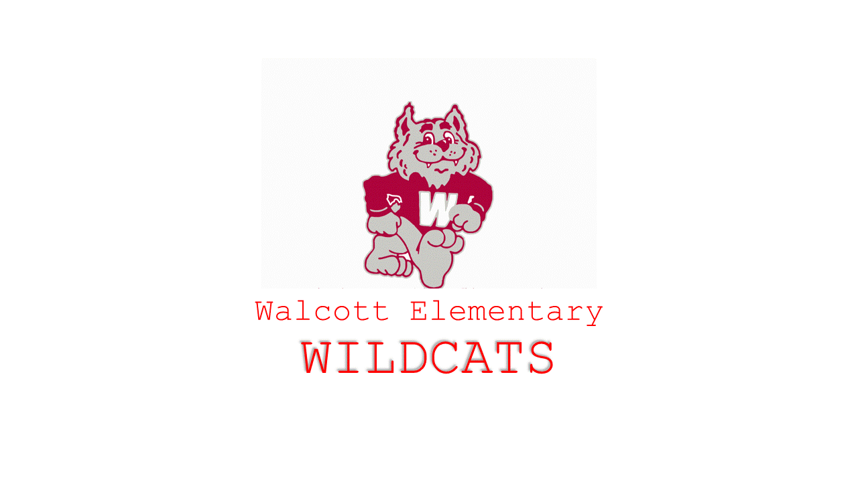
Return to In-Person Instruction
and
Continuity Plan

Return to In-Person Instruction and Continuity Plan
Walcott ISD is excited to return to school for the 2021-2022 year. Last year our staff and students worked tirelessly to maintain the protocols we had in place to continue face-to face instruction. We appreciated the support from our parents and families because we would have never been able to complete the year as safely as we did without you. Again, there is no way to completely eliminate the transmission risk of COVID-19 at schools, but we will do our best to mitigate those possibilities that come our way. Below you will find a plan that we have developed over the summer to address the health and prevention measures for our school.
Walcott ISD is committed to ensuring students have an equitable experience, access high quality instruction and are engaged in learning, therefore Walcott ISD will provide in-person, on campus instruction for all students. As we begin the 2021-2022 school year the following expectations will guide our instructional decisions.
- Students will engage in high quality learning experience aligned to TEKS Resource System and Texas Essential Knowledge and Skills (TEKS)
- Students will receive both formative and summative assessments to ensure they are making adequate progress in their grade-level curriculum.
- Classroom teachers will utilize Google Classroom, Class Link, ZippSlip and Class DoJo as their Learning Management System (LMS), to effectively communicate with parents and ensure a virtual platform is available.
- Students will receive extra support during Wildcat Hour which will be offered Monday-Thursday to all students to allow more time and support for learning loss related to COVID 19 and as part of Accelerated Instruction. This will be offered in the classroom or in a small group setting.
Walcott ISD is committed to ensuring that all students learn and are engaged, as well as providing consistency in high quality instruction and learning tools for all students.
If you have any questions, please email your questions to: darla.bryant@region16.net .
Please note that details are subject to change based on guidelines from local, state, and federal authorities.

School Calendar

Guidelines for 2021-22 School Year
Registration
All students will need to register for the 2021-22 school year online. All parents will be required to register their child via ZippSlip.
Learning Options
Face to Face Learning
Full time in-person on campus learning, with additional hygiene and disinfection procedures
- Social distancing will be observed in areas where practical.
- Facial covering will be provided for students, staff, or guests if they choose to wear them.
- Students must bring a personal water bottle to use with the hydration stations.
- 90% attendance rule will be in effect (TEC 25.092).
Virtual Learning or Hybrid Learning
Will only be used if a student is determined to need quarantine with COVID-19.
Grading
Walcott ISD sends progress reports to parents/guardians at the 3-week and 6-week mark of the grading period. Those dates can be found on the Walcott ISD District calendar.
Extracurricular/UIL
Walcott ISD will follow all UIL and district guidelines for extracurricular activities for the 2021-2022 school year.
Social, Emotional, and Mental Health Needs
Walcott ISD utilizes many avenues to address the social, emotional, and mental health needs of both students and staff. The PAX Behavior Game program was implemented for the 21-22 school year and as of February 2022 staff and students are seeing the benefits of the program.
Technology
Walcott ISD continually works to improve and build our technology services. The Technology Student Use Policy will be covered in classes the first week of school. Student Chromebooks will be distributed in the early weeks of school.

Transportation
Walcott ISD does provide no-cost transportation to our rural students. It is important to notify the school, or your bus driver, if your student is experiencing any of the COVID-19 symptoms. Please keep your child home until those symptoms cease or cleared by a physician. Temperature checks will continue each morning when students board the bus.
Cleaning and Maintaining Healthy Facilities
We will deploy layers of mitigation strategies to promote good hygiene and safety practices. We feel that due to these mitigation strategies, we saw the minimal transmission of COVID-19 or other viruses at school last year.
- We will continue cleaning and disinfecting of facilities. Our custodial staff uses disinfectants and sanitizers to disinfect large areas and kill airborne viruses.
- Classroom teachers use disinfectants on student desks and other areas of the classroom that have a tendency to be touched (doorknobs, light switches, etc.)
- Custodial cleaning and sanitization protocols will be utilized for disinfecting frequently touched surfaces.
- We will continue to contract with GermBlast to disinfect the school and buses.
Frequent Hand Washing or Hand Sanitizing
Students and adults will engage in frequent hand washing and/or hand-sanitizing upon arrival, before and after meals, after bathroom use, and after coughing or sneezing.
Face Coverings and Mask
Face coverings will no longer be required for any student or staff member; however, masks may be worn by those who feel more comfortable doing so. Schools are required to comply with the governor’s executive order regarding face coverings. At this time, masks for students and staff are optional.
Daily Self-Checks and Monitoring
- Student and staff wellness checks should be conducted at home on a daily basis before coming to school
- Students and staff should stay home if they are feeling sick, have COVID-19 symptoms, or have a temperature over 100.3
Seating and Social Distancing
- Assigned seating may be used as appropriate
- Desks or tables will be socially distanced as appropriate and instructionally possible.

Positive COVID-19 Cases
- Positive cases will be reported to the local health department
- Staff and students must report to campus/district administration if they are test confirmed with COVID-19, and, if so, they must remain off campus until they meet the criteria for re-entry provided by their doctor or local health department
- Contact tracing, isolation, and quarantine protocols will continue to occur to reduce the spread of COVID.
Procedures for Walcott
As the information from local, state and federal authorities’ changes, these procedures could be modified. Walcott will communicate any changes to parents. As we begin the school year, please note the following:
Lunch Procedures
Parents will be allowed to eat lunch with their child/children. Please notify the school that you will be visiting beforehand. Please monitor your health and use the COVID 19 check list.
Recess
Recess groups will be in smaller numbers on the playground. PK by themselves, K5-2nd and 3rd-6th
Parents on Campus
- Meet the teacher, assemblies, open houses, parent conferences, etc. will be held in person.
- Virtual parent conferences will still be available.
Special Events
Field Trips, parties, and special events will resume in 2021-22
Water Fountains
Walcott has purchased and installed refillable water bottle stations. Parents are encouraged to provide water bottles for their children.
Compliance
Walcott ISD will comply with applicable state and federal employment and disability laws, workplace safety standards, accessibility standards to address individual needs, guidance from TEA, and recommendations from the CDC. Plans will remain flexible to accommodate potential changes and these guidelines may be modified as needed. We will continue to provide the most consistent learning environment for our students. As adjustments may be necessary throughout the year, it will be our priority to keep the community informed of those changes.
Health/Safety Efforts Underway for the New School Year/Daily Protocols
- Monitor the potential impact of COVID 19 in Oldham/Deaf Smith County and follow guidance provided by local health organizations.
- Using preventative, antimicrobial misting systems in all facilities and on buses to thoroughly and widely disinfect daily. The District also disinfects locker rooms, weight rooms, and equipment.
- Temperature checks daily before students enter the building or buses.
- Hand sanitizer located at all facility entrances.
- Hand sanitizer and disinfectant will be available in all classrooms.
- Visitors will be temperature checked and health screened before entering the facility.
- Social distancing will be enforced when feasible.
- Hand washing and or hand sanitizing required frequently throughout the day. Proper self-care habits will be taught.
- Face covering will not be mandated at this time. District will provide face coverings for any student, staff member or visitor that asks for one.
- Students that develop symptoms of COVID-19 during the school day will be immediately separated from the student population. The student will be asked to put on a school supplied mask and wait in the nurse’s observation room until picked up by a parent or guardian.
- Students who report feeling feverish will be immediately temperature checked to determine if they are symptomatic for COVID-19.
- Separate care areas have been created for sick and well populations. Well student/staff and injury care will be done in the nurse’s office. Students/staff exhibiting symptoms that may indicate COVID-19 will be cared for in the observation room located in the classroom directly next to the nurse’s office.

Parents must ensure they do not send a child to school on campus if the child has COVID-19 symptoms or is lab-confirmed with COVID-19. Students that have recently begun experiencing any of the following symptoms in a way that is new or not normal for them, will need to follow TEA guidance for COVID-19 symptoms:
COVID-19 Symptoms
- Feeling feverish or a measured temperature greater than or equal to 100.0 degrees Fahrenheit
- Loss of taste or smell
- Cough
- Difficulty breathing
- Shortness of breath
- Headache
- Chills
- Sore Throat
- Shaking or exaggerated shivering
- Significant muscles aches or pains
- Diarrhea
Students experiencing fever, or any of the above symptoms in a way that is not normal for them, will need to remain off campus until they meet the criteria for school re-entry. During the time of illness, and while awaiting re-entry, the student will temporarily attend school virtually and will be able to meet attendance requirements in that manner. Parents will need to contact the campus principal, secretary or school nurse for further guidance and instructions.
Teachers and staff will need to self-screen for COVID-19 symptoms before coming onto campus each day. The self-screening should include taking their own temperature. Staff must also report to the school system if they themselves have COVID-19 symptoms or are lab-confirmed with COVID-19, and, if so, they must remain off campus until they meet the criteria for re-entry. Additionally, they must report to the school system if they have had close contact with an individual who is lab-confirmed with COVID-19.

Continuity of Services

Instructional Settings and Continuity of Services

We will continue to work towards our campus and district academic goals, while consistently providing expanded services and extracurricular activities.

Assessing and Addressing the Impact of Learning Loss

Walcott ISD will continue to examine data from screeners, formative assessments, summative assessments, and other data to provide staff with information vital to providing targeted interventions. Student progress will be monitored and adjustments to interventions will be made as appropriate. Walcott ISD will offer opportunities to limit learning loss, which may include:

- Small group interventions
- During the day tutorials
- STAAR tutorials
- Summer School
- Technology

Mental Health and Behavioral Supports

Walcott ISD will continue to support students academically, socially and emotionally. In addition, Walcott ISD will continue to offer various programs, resources, and partnerships that benefit the mental, social and emotional needs of the student, which may include:

- Professional development for educators
- Offer in school counseling
- Continue with community partnerships to benefit the whole child
- Ensure the continuity of food service programs
- PAX Good Behavior Game

Updated – Summer 2021
Reviewed – September 1, 2021
Reviewed and Updated – Collaboration meeting on February 8, 2022

